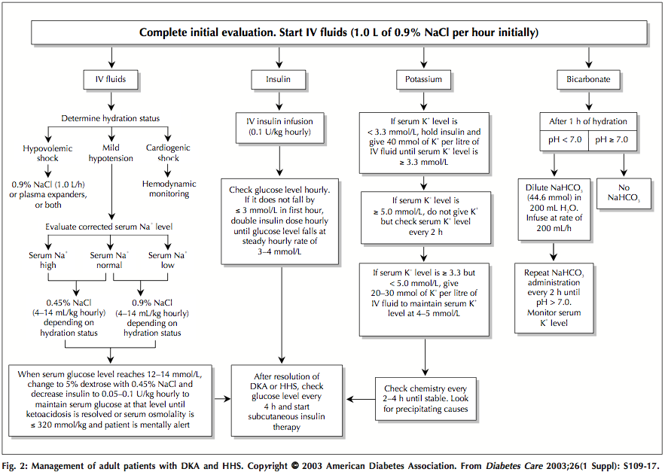

Chaisson, J. L., Aris-Jilwan, N., Belanger, R., Bertrand, S., Beauregard, H., Ekoe, J. M., Fournier, H., & Havrankova, J. (2003). Diagnosis and treatment of diabetic ketoacidosis and the hyperglycemic hyperosmolar state. *Canadian Medical Association Journal, 168*(7), 859-866.